**Titanic Data Analysis**

**1. Associated Data Files**

https://drive.google.com/file/d/0ByJLBTmJojjzNmV0dk1EMmwwQ1U/view?usp=sharing

**DATA SET DESCRIPTION**

Column 1 : PassengerId

Column 2 : Survived (survived=0 & died=1)

Column 3 : Pclass

Column 4 : Name

Column 5 : Sex

Column 6 : Age

Column 7 : SibSp

Column 8 : Parch

Column 9 : Ticket

Column 10 : Fare

Column 11 : Cabin

Column 12 : Embarked

**2. Problem Statements**

You can use any of the technologies like Map Reduce, Pig or Hive of your choice.

Note: You need to copy the data set into HDFS using flume and send the screen shot of that with the project solution

1. In this problem statement we will find the average fare of each class.

2. In this problem statement we will find the number of people alive in each class and are embarked in Southampton.

3. In this problem statement we will find out number of male and female people died in each class.

**Solution**

Created directory "titanicdata" to store the data in HDFS, which will act as a sink while transferring data using flume.

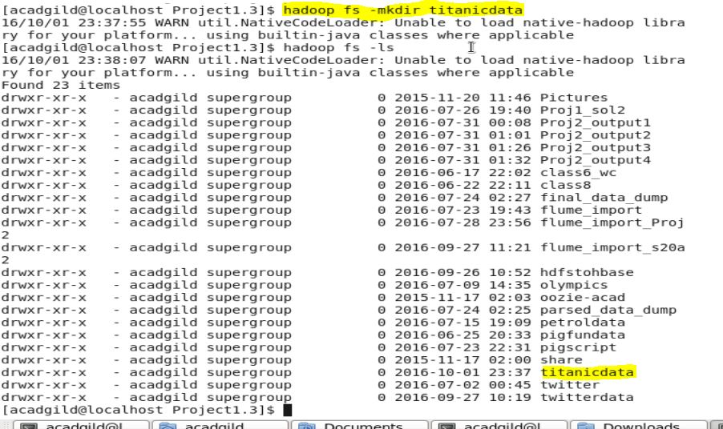

Created "TitanicDataSource" folder on local drive which will act as a source to transfer data using flume.

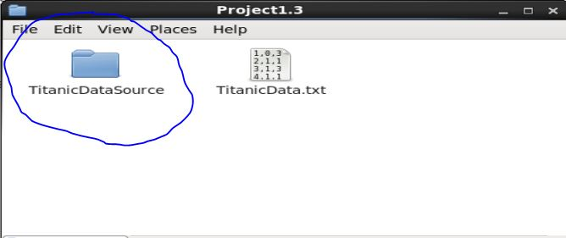

Created configuration file for data transfer using flume.

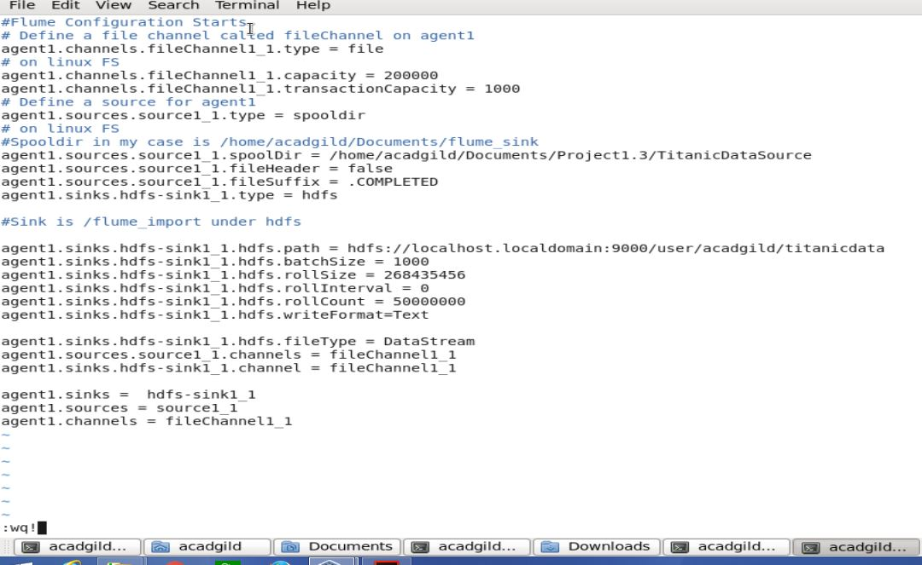

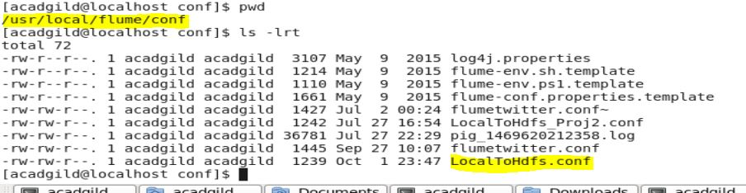

Started flume agent.

C:\Users\RAKESH\Desktop\Screenshot\Project1.3\S9.JPG

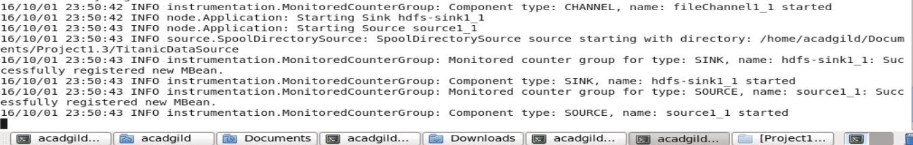

Copied the data file to source folder.

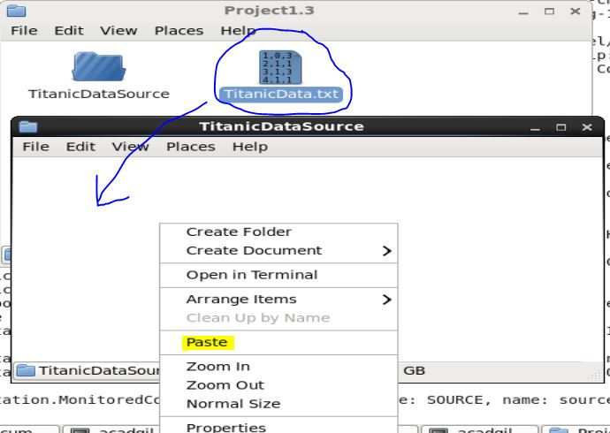

The data file's extension changed to COMPLETED as mentioned in configuration file. It means that data has loaded into HDFS.

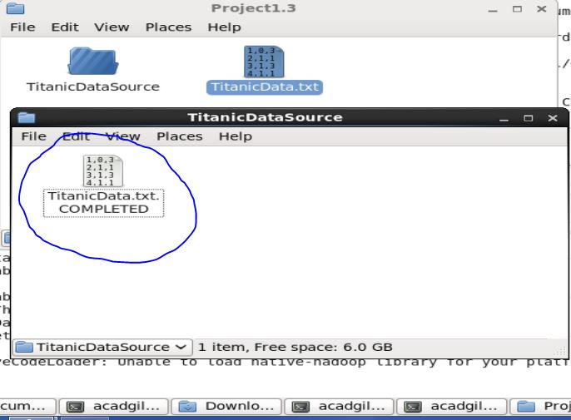

**Problem 1:**

Created the below Pig script and ran using following command in MapReduce mode:

**C:\Users\RAKESH\Desktop\Screenshot\Project1.3\S13.JPG**

Pig Script:

rawdata = LOAD '/user/acadgild/titanicdata' USING PigStorage(',') AS (passengerid: int,survived: int,pclass: int,name: chararray,sex: chararray,age: int,sibsp: int,parch: int,ticket: chararray,fare: float,cabin: chararray,embarked: chararray);

generate_class = FOREACH rawdata GENERATE pclass,fare;

group_class = GROUP generate_class by pclass;

avg_fare = FOREACH group_class GENERATE group as pclass, AVG(generate_class.fare);

dump avg_fare;

Output:

(1,84.15468752825701)

(2,20.66218318109927)

(3,13.675550210257411)

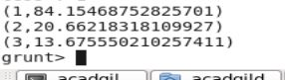

**Problem 2:**

Created the below Pig script and ran using following command in MapReduce mode:

C:\Users\RAKESH\Desktop\Screenshot\Project1.3\S14.JPG

Pig Script:

rawdata = LOAD '/user/acadgild/titanicdata' USING PigStorage(',') AS (passengerid: int,survived: int,pclass: int,name: chararray,sex: chararray,age: int,sibsp: int,parch: int,ticket: chararray,fare: float,cabin: chararray,embarked: chararray);

generate_filter = FILTER rawdata by survived == 0 AND embarked == 'S';

generate_pclass = FOREACH generate_filter GENERATE pclass;

group_pclasss = GROUP generate_pclass by pclass;

count_people = FOREACH group_pclasss GENERATE group as pclass, COUNT(generate_pclass.pclass);

dump count_people;

Output:

(1,53)

(2,88)

(3,286)

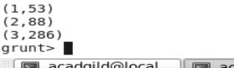

**Problem 3:**

Created the below Pig script and ran using following command in MapReduce mode:

C:\Users\RAKESH\Desktop\Screenshot\Project1.3\S15.JPG

Pig Script:

rawdata = LOAD '/user/acadgild/titanicdata' USING PigStorage(',') AS (passengerid: int,survived: int,pclass: int,name: chararray,sex: chararray,age: int,sibsp: int,parch: int,ticket: chararray,fare: float,cabin: chararray,embarked: chararray);

generate_died = FILTER rawdata by survived == 1;

generate_class = FOREACH generate_died GENERATE pclass,sex;

filter_male = FILTER generate_class by sex == 'male';

group_male = GROUP filter_male by pclass;

count_male = FOREACH group_male GENERATE group as pclass,COUNT(filter_male.sex) AS m;

filter_female = FILTER generate_class by sex == 'female';

group_female = GROUP filter_female by pclass;

count_female = FOREACH group_female GENERATE group as pclass,COUNT(filter_female.sex) AS f;

join_count = JOIN count_male by pclass, count_female by pclass;

final_count = FOREACH join_count GENERATE count_male::pclass,m,f;

dump final_count;

Output:

(1,45,91)

(2,17,70)

(3,47,72)

